Name: Pranali Sonawane
Subject: CCNA
Date: 19-11-2025
Lab 30– : ACLs on Three routers using Standard ACL and Extended ACL.
First, take three routers (for example, 1841 models), three switches, and six PCs.Connect the routers, switches, and PCs using straight-through cables.Use a straight-through cable to connect the serial interfaces between the 3 routers.
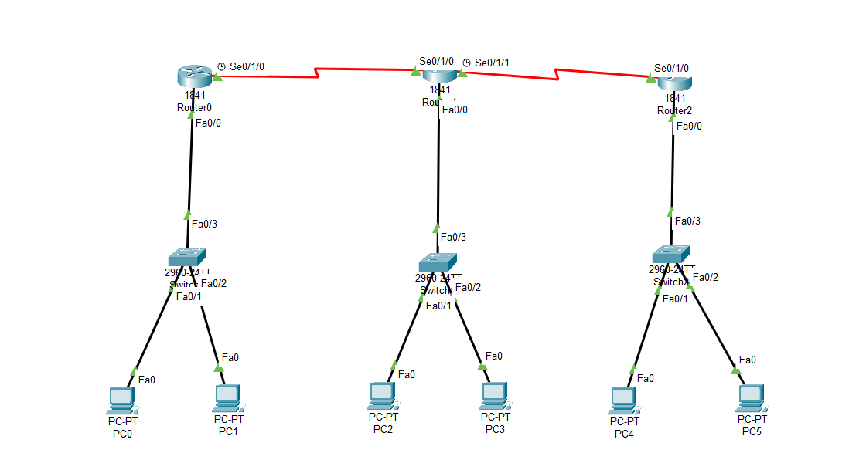
Configure PCs :
- PC0:
  - IPv4 Address: 10.0.0.2
  - Subnet Mask: 255.0.0.0
  - Default Gateway: 10.0.0.1
- PC1:
  - IPv4 Address: 10.0.0.3
  - Subnet Mask: 255.0.0.0
  - Default Gateway: 10.0.0.1
- PC2:
  - IPv4 Address: 20.0.0.2
  - Subnet Mask: 255.0.0.0
  - Default Gateway: 20.0.0.1
- PC3:
  - IPv4 Address: 20.0.0.3
  - Subnet Mask: 255.0.0.0
  - Default Gateway: 20.0.0.1
- PC4:
  - IPv4 Address: 30.0.0.2
  - Subnet Mask: 255.0.0.0
  - Default Gateway: 30.0.0.1
- PC5:
  - IPv4 Address: 30.0.0.3
  - Subnet Mask: 255.0.0.0
  - Default Gateway: 30.0.0.1

Open Router 0 – CLI prompt then type following commands
Router>enable
Router#configure terminal
Router(config)# interface fastEthernet 0/0
Router(config-if)# ip address 10.0.0.1 255.0.0.0
Router(config-if)#no shutdown
Router(config-if)#exit

Router(config)#interface serial 0/1/0
Router(config-if)#ip address 40.0.0.1 255.0.0.0
Router(config-if)#no shutdown
Router(config-if)#exit

Router(config)# interface fastEthernet 0/0
Router(config-if)# ip address 60.0.0.1 255.0.0.0
Router(config-if)#no shutdown
Router(config-if)#exit

Router(config)#router ospf 1
Router(config-router)#network 10.0.0.0 0.255.255.255 area 0
Router(config-router)#network 60.0.0.0 0.255.255.255 area 0
Router(config-router)#network 40.0.0.0 0.255.255.255 area 0
Router(config-router)#exit
Router(config)#exit
Router#show ip route
Router#show ip os nei

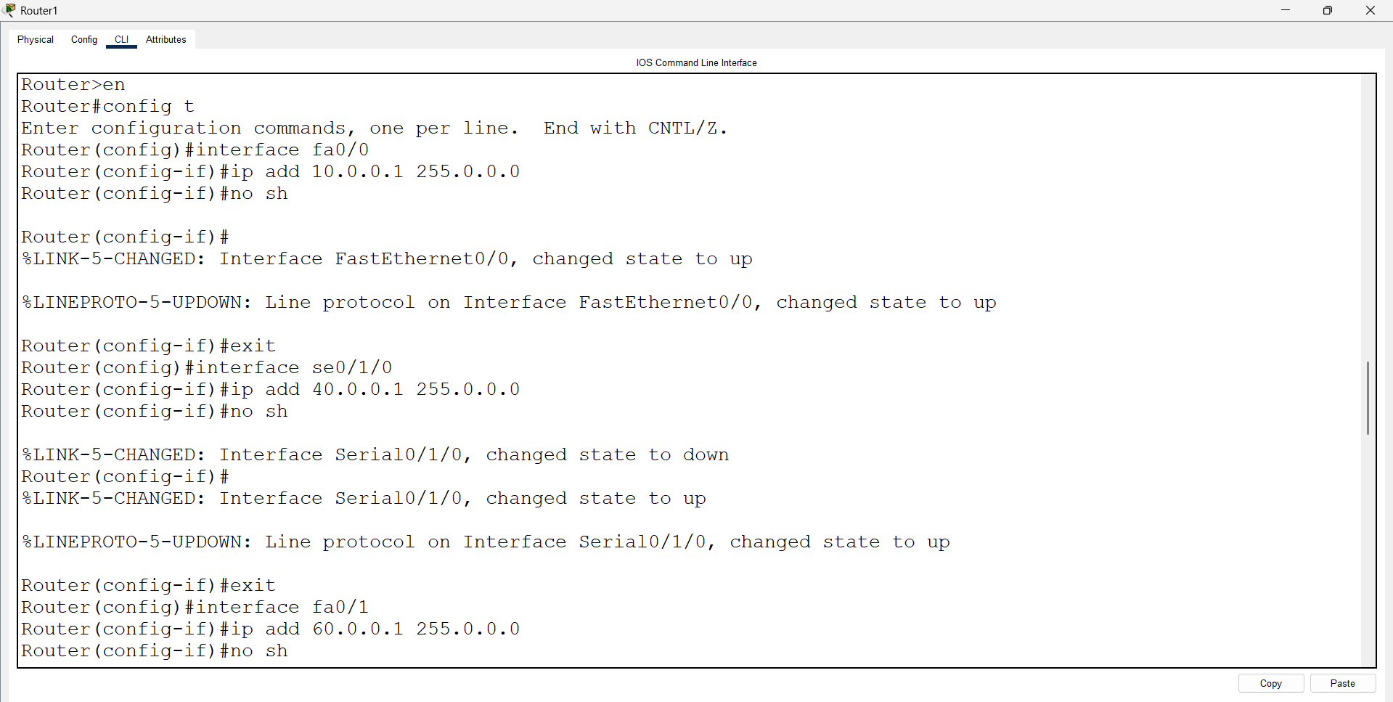
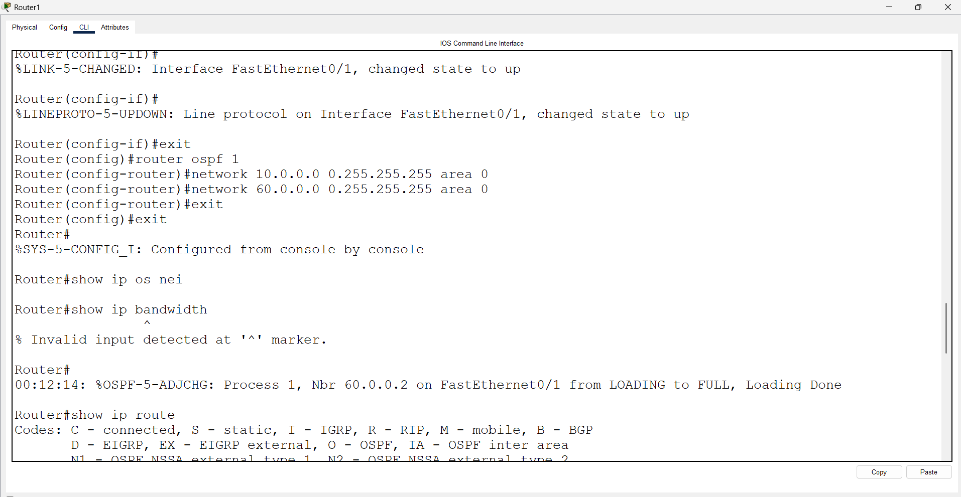

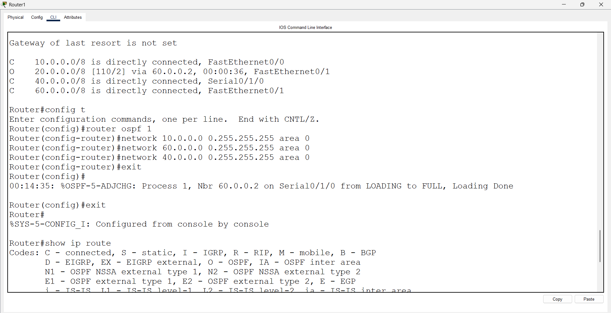
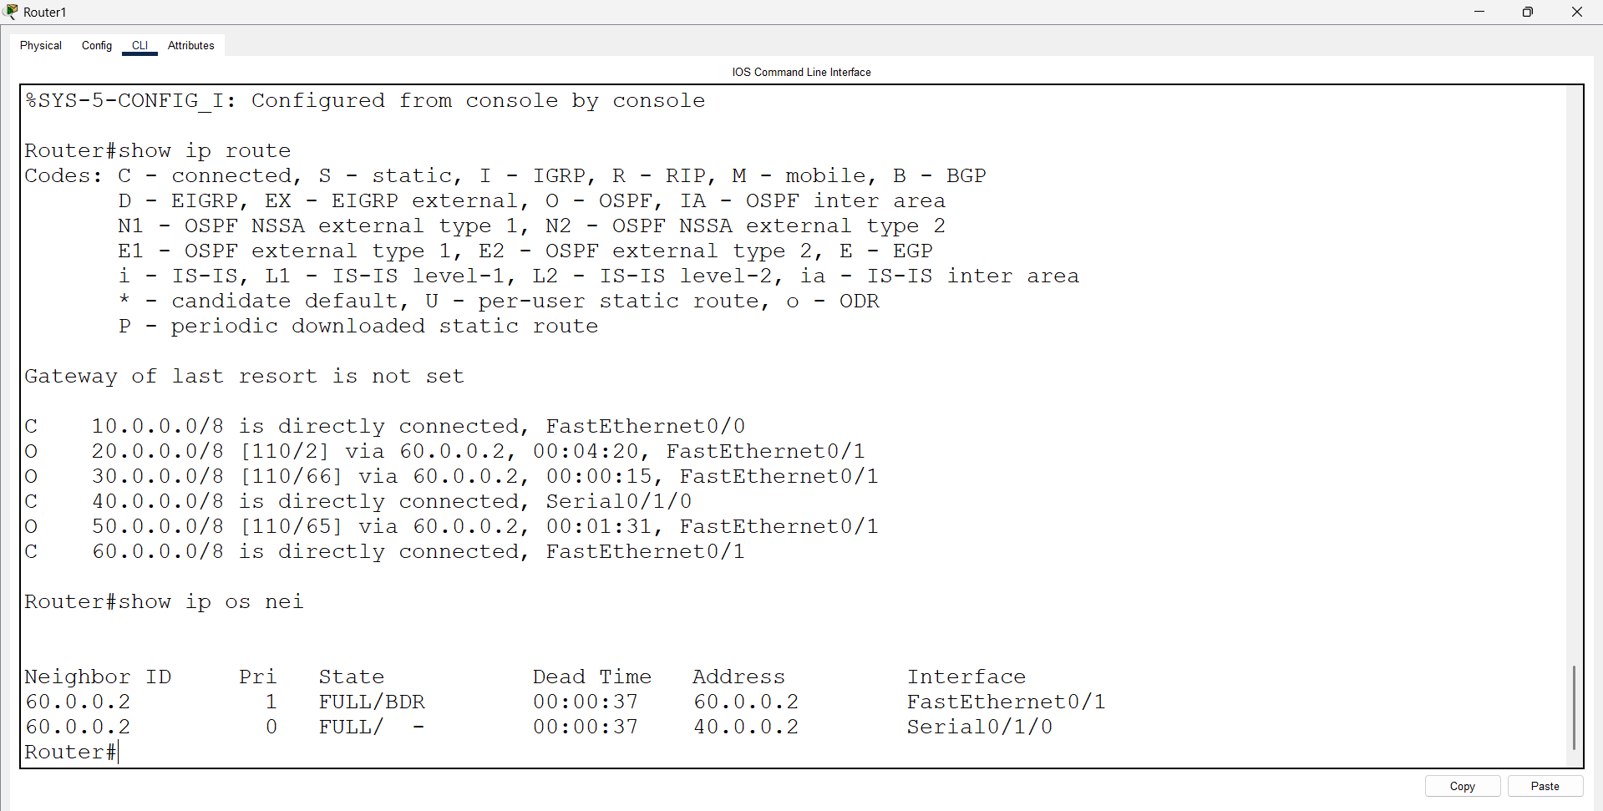

Router 0 - Standard ACL
Router>enable
Router#configure terminal
Router(config)#access-list 1 deny 10.0.0.0 0.255.255.255
Router(config)# interface fastEthernet 0/0
Router(config-if)# ip access-group 1 in (Ping is not Working )
Router(config-if)# no ip access-group 1 in (Ping is working )

Router 0 - Extended ACL:
Router>enable
Router#configure terminal
Router(config)#access-list 101 deny ip host 10.0.0.2 host 20.0.0.2
Router(config)#access-list 101 permit ip any any
Router(config)# interface fastEthernet 0/0
Router(config-if)# ip access-group 101 in
Router(config-if)# no ip access-group 101 in

Open Router 1 – CLI prompt then type following commands
Router>enable
Router#configure terminal
Router(config)# interface fastEthernet 0/0
Router(config-if)# ip address 20.0.0.1 255.0.0.0
Router(config-if)#no shutdown
Router(config-if)#exit

Router(config)#interface serial 0/1/0
Router(config-if)#ip address 40.0.0.2 255.0.0.0
Router(config-if)#no shutdown
Router(config-if)#exit

Router(config)# interface fastEthernet 0/1
Router(config-if)# ip address 60.0.0.2 255.0.0.0
Router(config-if)#no shutdown
Router(config-if)#exit

Router(config)#interface serial 0/1/1
Router(config-if)#ip address 50.0.0.1 255.0.0.0
Router(config-if)#no shutdown
Router(config-if)#exit

Router(config)#router ospf 1
Router(config-router)#network 20.0.0.0 0.255.255.255 area 0
Router(config-router)#network 40.0.0.0 0.255.255.255 area 0
Router(config-router)#network 50.0.0.0 0.255.255.255 area 0
Router(config-router)#network 60.0.0.0 0.255.255.255 area 0
Router(config-router)#exit
Router(config)#exit
Router#show ip route
Router#show ip os nei

Router 1 - Standard ACL
Router>enable
Router#configure terminal
Router(config)#access-list 2 deny 20.0.0.0 0.255.255.255
Router(config)# interface fastEthernet 0/0
Router(config-if)# ip access-group 2 in
Router(config-if)# no ip access-group 2 in

Self Study:
Router 1 - Extended ACL:
Router>en
Router#config t
Enter configuration commands, one per line. End with CNTL/Z.
Router(config)#access-list 102 deny ip host 20.0.0.2 host 10.0.0.2
Router(config)#access-list 102 permit ip any any
Router(config)#interface fa0/0
Router(config-if)#ip access-group 102 in
Router(config-if)#no ip access-group 102 in

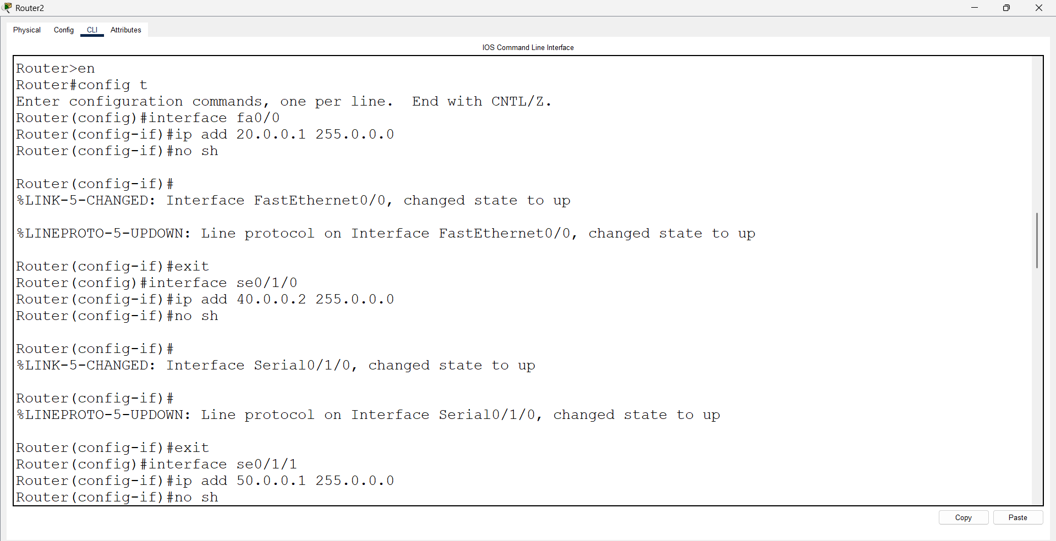
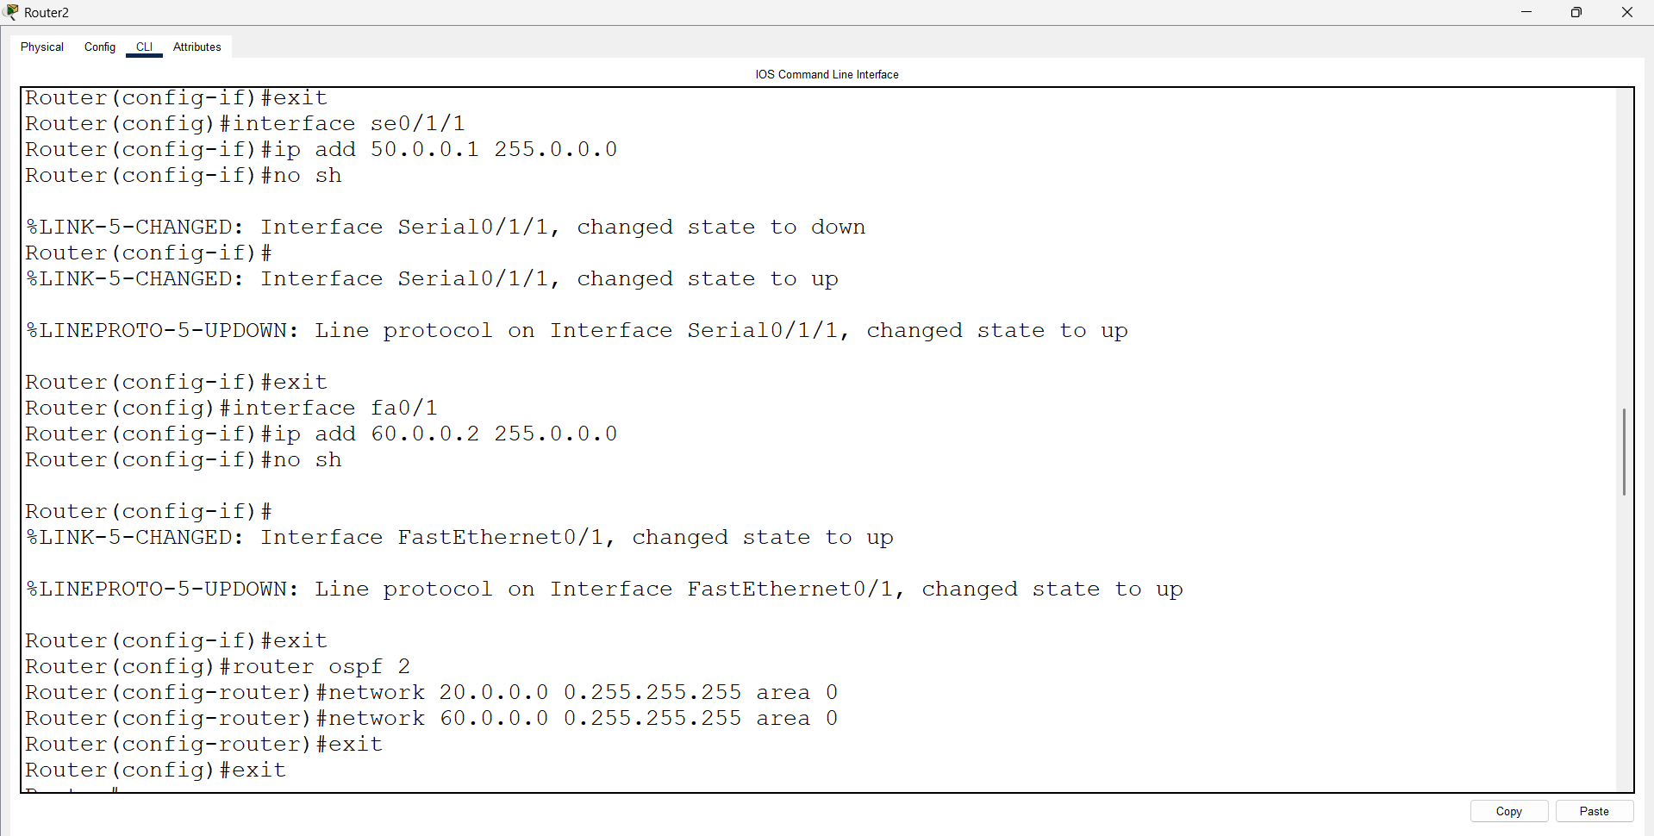

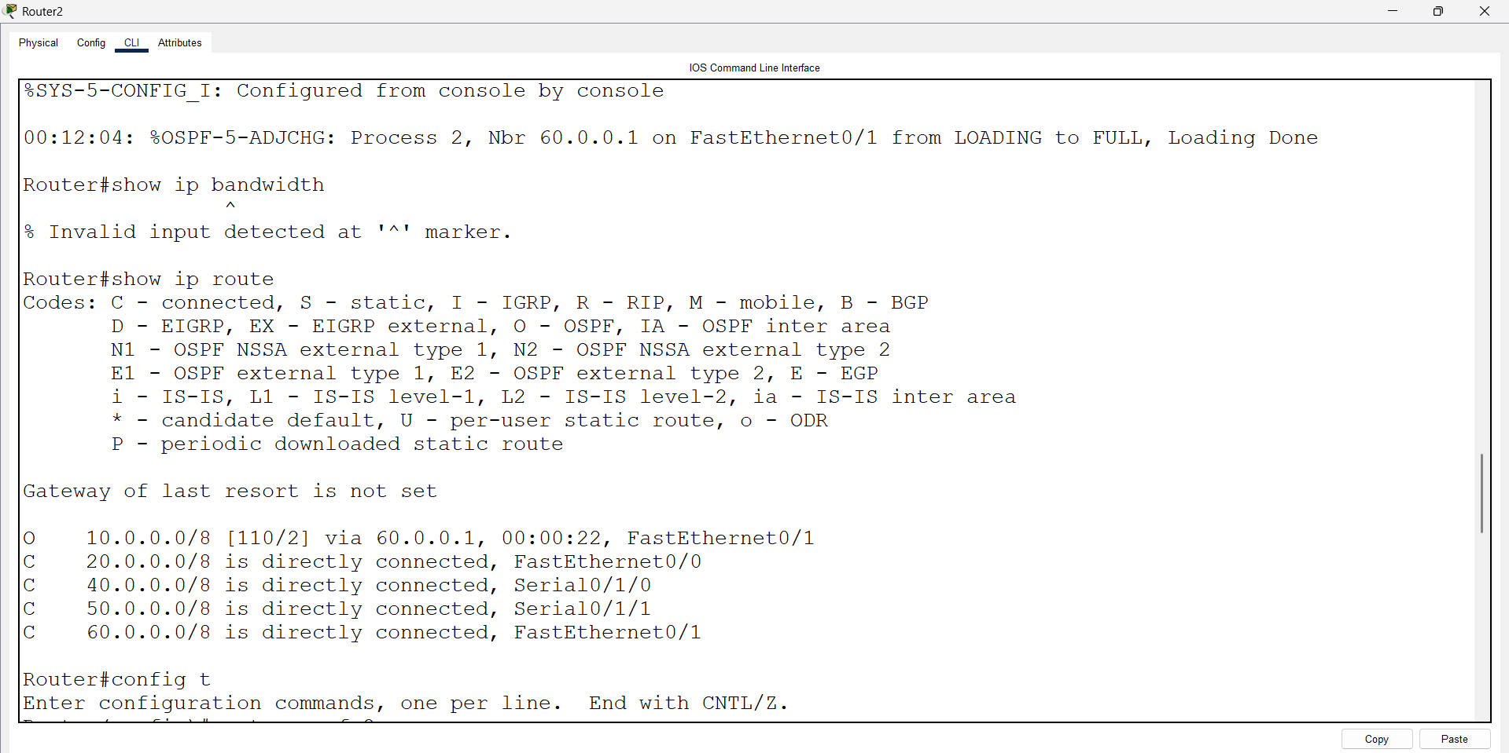
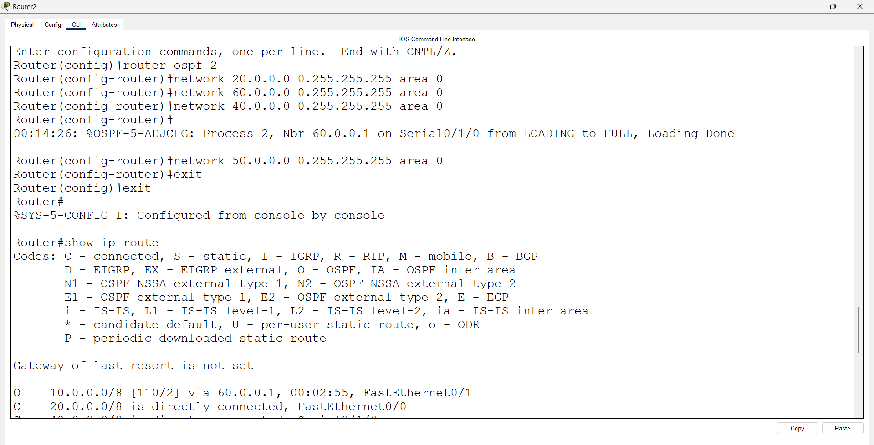
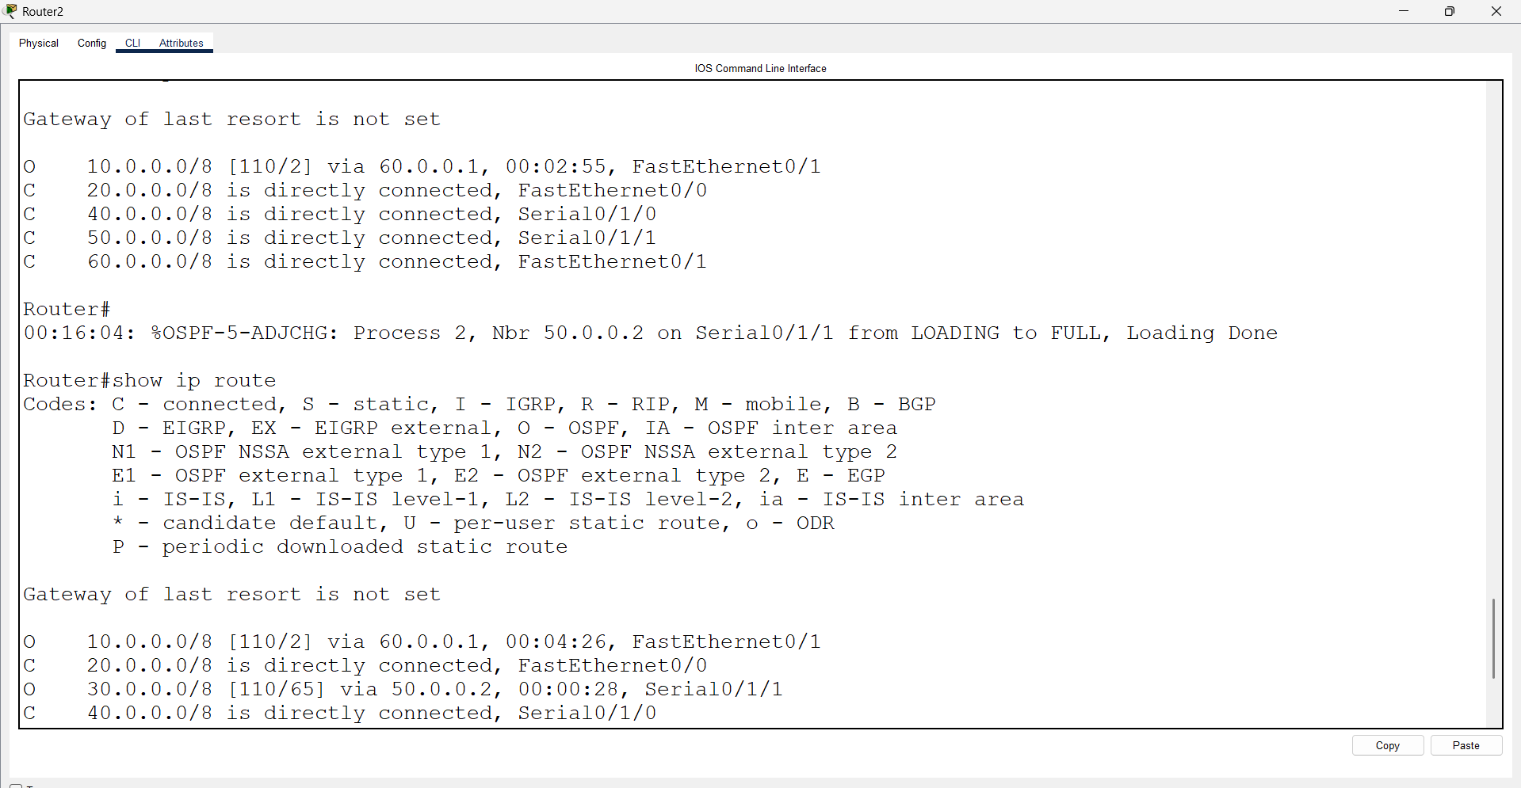
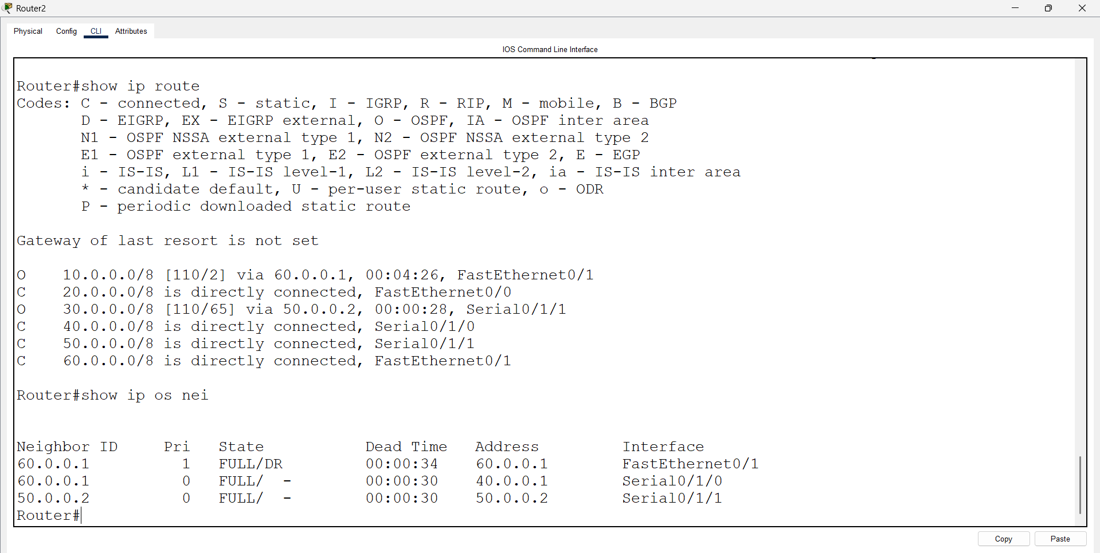

Open Router 3 – CLI prompt then type following commands
Router>enable
Router#configure terminal
Router(config)# interface fastEthernet 0/0
Router(config-if)# ip address 30.0.0.1 255.0.0.0
Router(config-if)#no shutdown
Router(config-if)#exit

Router(config)#interface serial 0/1/0
Router(config-if)#ip address 50.0.0.2 255.0.0.0
Router(config-if)#no shutdown
Router(config-if)#exit

Router(config)#router ospf 1
Router(config-router)#network 30.0.0.0 0.255.255.255 area 0
Router(config-router)#network 50.0.0.0 0.255.255.255 area 0
Router(config-router)#exit
Router(config)#exit
Router#show ip route
Router#show ip os nei

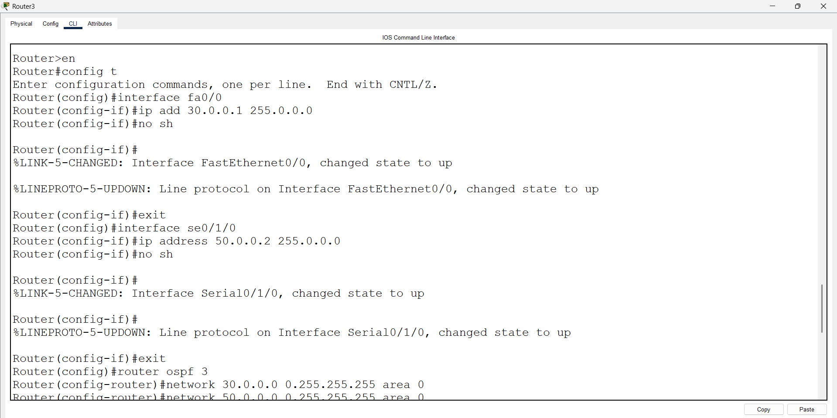
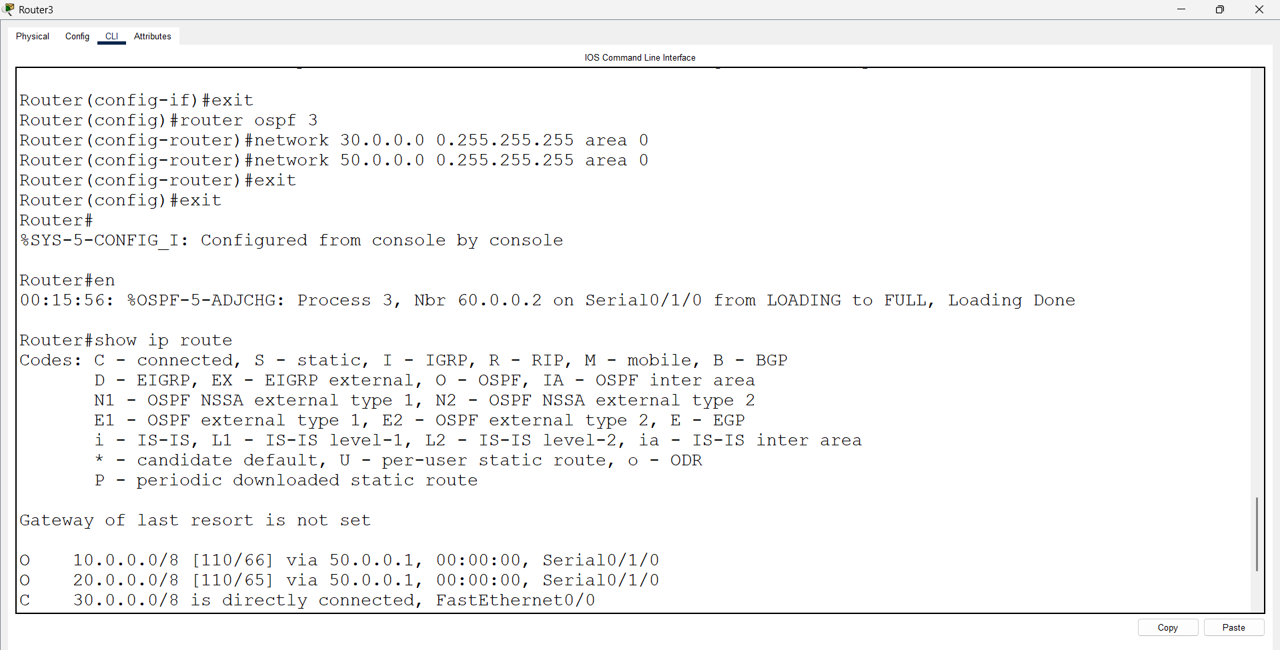
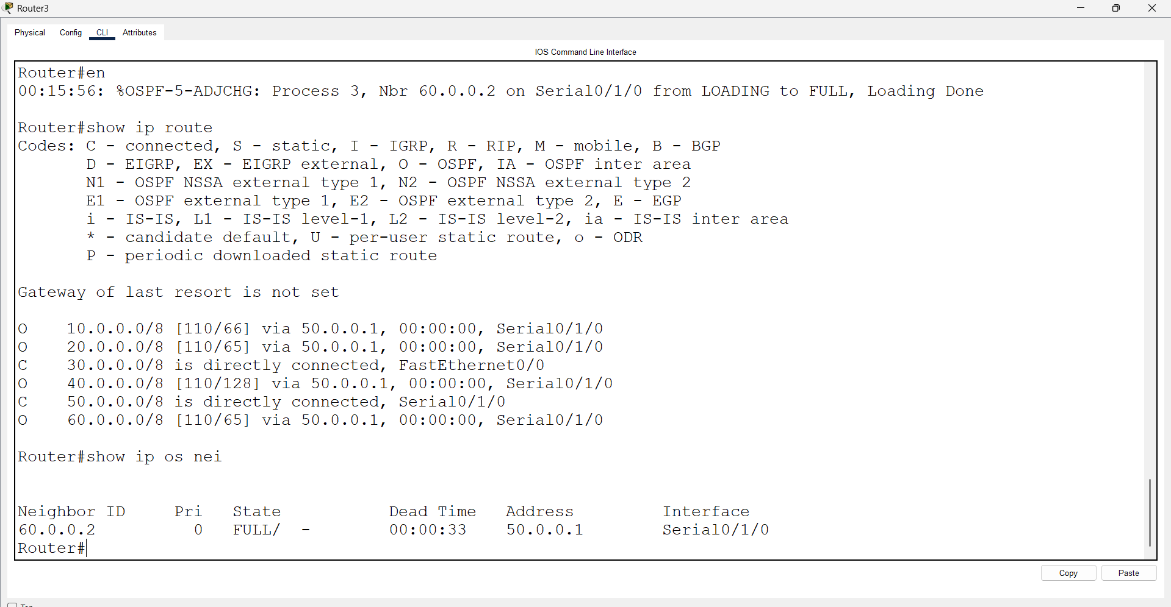

Router 2 - Standard ACL
Router>enable
Router#configure terminal
Router(config)#access-list 3 deny 30.0.0.0 0.255.255.255
Router(config)# interface fastEthernet 0/0
Router(config-if)# ip access-group 2 in
Router(config-if)# no ip access-group 2 in

One scnerios PC0 is ping is not unreachable to Router 2 30.0.0.1 and PC0 Telnet is working :

Router0> enable
Router0# configure terminal
Router0(config)# no access-list 101
Router0(config)# access-list 101 deny tcp host 10.0.0.2 host 30.0.0.1 eq 23
Route0(config)# access-list 101 deny ip host 10.0.0.2 host 30.0.0.1
Router0(config)# access-list 101 permit ip any any
Router0(config)# interface Fa0/0
Router0(config-if)# ip access-group 101 out
Router0(config-if)# end
